Instructions to submit a Conference Paper proposal:
You are required to submit an extended abstract between 2000 to 2500 words. If your abstract is accepted, you will be invited to give a 20 minute in person presentation at IDCC26 with an additional five minutes for questions. For further details, please see: https://www.dcc.ac.uk/events/idcc26.
The submission should observe the word limit, be written using clear language, accurately reflect the title, present a coherently structured argument, with sufficient context for the reader, and concrete examples where appropriate.
Upon acceptance of your proposal, you will be invited to write-up your paper in full, following the submission guidelines of the International Journal of Digital Curation (IJDC) – https://ijdc.net/index.php/ijdc/about .
All submitted papers that are presented at IDCC26 will be published in IJDC (International Journal of Digital Curation) as Conference Papers, following a brief editorial review.
Alternatively, you can choose to submit your paper for further peer review, either as a General Article or as a Research Paper. Please refer to the IJDC Editorial Guidelines on the 'About the Journal' page for further guidance on the different peer-review criteria for Research Papers and General Articles.

If generative AI was used to develop a submission, or any part of a submission, its use and purpose must be described. Authors should be prepared to provide information on tools used and prompts given to generate content used in their submission. Authors are responsible and accountable for providing appropriate scrutiny to AI generated content to avoid inaccuracies and plagiarism. The use of generative AI in creating content does not confer authorship to the tool concerned. You can read our full guidance on AI use for the conference here:
Guidance on use of generative AI tools.

Decisions on acceptance are ultimately made by the IDCC Programme Committee, but the committee's decision is heavily reliant on the experience and evaluations of our reviewers. Submissions are reviewed by a minimum of two reviewers who are asked to assess on the following criteria:

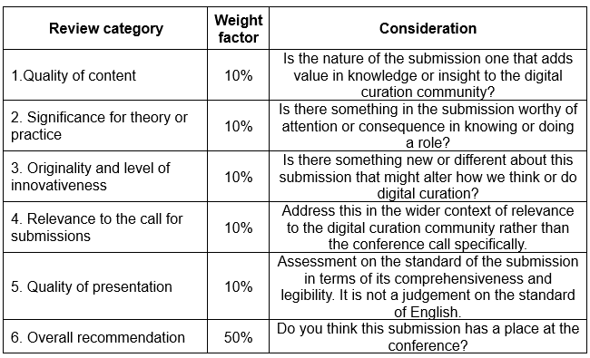

Reviewers also provide comments on the submission that explain their evaluation in a detailed and clear manner, point out strengths and weaknesses, and provide suggestions for constructive and objective improvement.

Title of proposal
Abstract

