Instructions to submit a Lightning Talk proposal:
Lighting talks are an opportunity to showcase work in progress or completed projects that you believe offers insights or practical lessons that advance digital curation research or practice. Treat IDCC26 as a stage where you can make your work known and potentially recruit collaborative partners.
You should submit an abstract of between 300-500 words that describes the work you are proposing to present, and its relevance to the IDCC call for submissions.
Proposed lightning talks are considered on the basis of the abstract submitted. If accepted, you will be invited to give a 10-minute in person presentation at IDCC with 5 min afterwards for audience questions. For further details about the IDCC26 conference, please visit https://www.dcc.ac.uk/events/idcc26 .

If generative AI was used to develop a submission, or any part of a submission, its use and purpose must be described. Authors should be prepared to provide information on tools used and prompts given to generate content used in their submission. Authors are responsible and accountable for providing appropriate scrutiny to AI generated content to avoid inaccuracies and plagiarism. The use of generative AI in creating content does not confer authorship to the tool concerned. You can read our full guidance on AI use for the conference here:
Guidance on use of generative AI tools.

Lightning Talks presented at IDCC may optionally be submitted to the International Journal of Digital Curation in the form of a Brief Report (2,000 - 4,000 words). Brief Reports are subject to a light-weight editorial review. Further guidance is available on the IJDC website, see: https://ijdc.net/index.php/ijdc/about .

Decisions on acceptance are ultimately made by the IDCC Programme Committee, but the committee's decision is heavily reliant on the experience and evaluations of our reviewers. Submissions are reviewed by a minimum of two reviewers who are asked to assess on the following criteria:
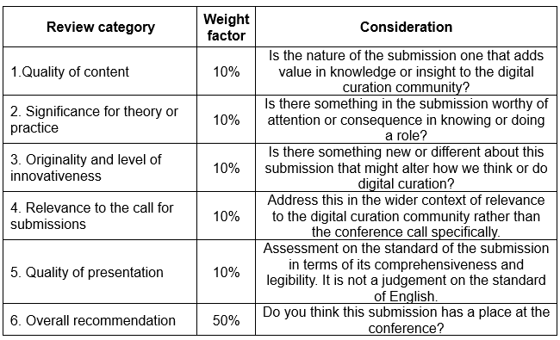
Reviewers also provide comments on the submission that explain their evaluation in a detailed and clear manner, point out strengths and weaknesses, and provide suggestions for constructive and objective improvement.

Title of proposal
Abstract

